# Learning Maths for Machine Learning and Deep Learning 为机器学习和深度学习而学习数学

原文链接：  
原文链接：

While I did learn a lot of maths while doing my engineering degree, I forgot most of it by the time I wanted to get into Machine Learning. After I graduated I never really had a need for any of the maths. I did a lot of web programming which relied on logic and I can honestly say that with each system with the word ‘Management’ in the title I lost a third of my math knowledge! I’ve programmed extensions for Learning Management Systems, Content Management Systems and Customer Relationship Management Systems — I’ll leave you to figure out how much math apptitude I had after working with these systems. At the moment I’ve got good data science skills and can use a variety of ML and DL algorithms. I’ve successfully completed a number of MOOCs (e.g., Deep Learning Foundations from Udacity and Andrew Ng’s new Coursera courses). I can use Scikit Learn, TensorFlow and Kera’s. …. but I have rough ideas for creating new variants of algorithms. At the moment I really want to create a new kind of interactive topic modeling algorithm. I’ve felt stuck due to my lack of maths knowledge. In my travels trying to re-learn some basic maths, I’ve come across a couple of books that have been written by people with the art of explanation. These books have made a tremendous difference as they are able to convey complex concepts in a very simple manner. I am writing this blog post to share these great resources especially for programmers. The books cover Calculus and Linear Algebra. I’ve not found an equivalent Probability and Statistics book yet — If you know of one please leave a comment or tweet .  
虽然我在攻读工程学位的时候确实学了很多数学，但当我想进入机器学习的时候，我已经忘记了其中的大部分。毕业后，我对数学一窍不通。我做了很多基于逻辑的网络编程，我可以诚实地说，每一个标题中有“管理”一词的系统，我失去了三分之一的数学知识！我已经为学习管理系统、内容管理系统和客户关系管理系统编写了扩展程序，我将让您了解在使用这些系统后我有多少数学应用程序。目前我有很好的数据科学技能，可以使用各种ML和DL算法。我已经成功地完成了一些MOOC（例如，来自Udacity的深度学习基金会和Andrew Ng的新CurSera课程）。我可以用Scikit学习，TensorFlow和Kera的…。但我对创建新的算法变体有一些粗略的想法。目前我真的很想创建一种新的交互式主题建模算法。由于我缺乏数学知识，我感到很为难。在我试图重新学习一些基础数学的旅行中，我偶然发现了几本书，它们是由具有解释艺术的人写的。这些书产生了巨大的不同，因为它们能够以非常简单的方式传达复杂的概念。我写这篇博文是为了分享这些伟大的资源，特别是为程序员。这些书涵盖微积分和线性代数。我还没有找到一本与概率论和统计学相当的书 - 如果你知道，请留下评论或推特。

### Calculus Made Easy by S. Thompson 汤普森的微积分

Learn calculus from a book written in 1914! The is freely available. This book is simply amazing. The English is a bit old style but the explanations are timeless. Thompson makes calculus super easy. Optimization of a cost function is core to ML and DL and this book will help you understand the basics of minimization. Those update rules in gradients decent won’t seem like magic anymore. Just read the prologue — its set the tone for the rest of the book…  
从1914年写的一本书中学习微积分！免费提供。这本书简直太棒了。英语有点过时，但解释是永恒的。汤普森使微积分变得非常简单。成本函数的优化是ML和DL的核心，本书将帮助您理解最小化的基本原理。那些在渐变中的更新规则看起来不再像魔术了。只要读一读序言，它就为这本书的其余部分定下了基调…

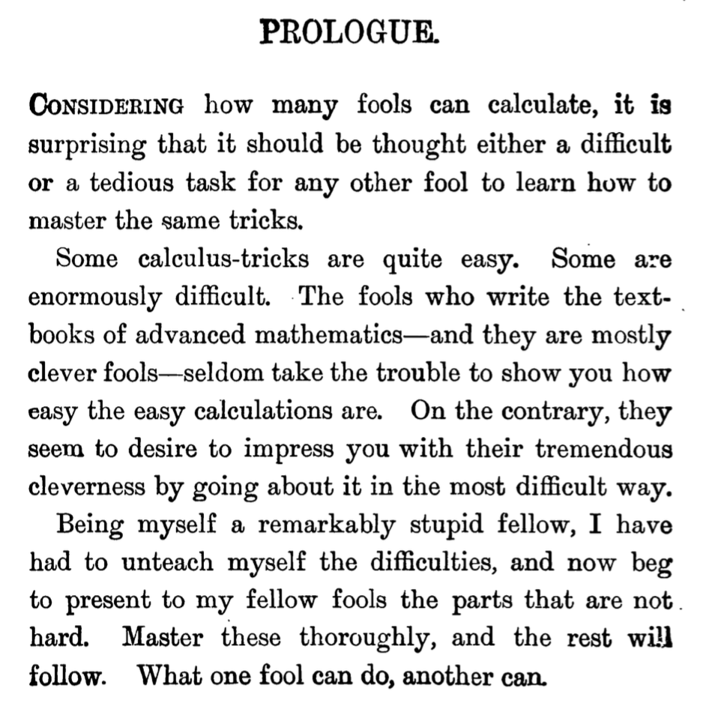

img  
img公司

The Prologue from Calculus Made Easy by S. Thompson  
S.汤普森的微积分序幕

### Coding the Matrix by P. N. Klein 用P.N.Klein编码矩阵

Most Linear Algebra books start easy but then concepts like image, basis, dimension, orthogonalization, eigenvectors are introduced in a completely abstract way. Most Linear Algebra books fail to even introduce real world applications and its hard to see where or why you would use the math. Matrix multiplication is a good example of something I learnt but never truely understood (i.e., why is was not performed element by element). is different! You actually get to build your own linear algebra library while improving your Python programming skills! The book is full of practical computer science applications (e.g. fix the perspective of a whiteboard photograph).  
大多数线性代数书籍开始容易，但随后概念，如图像，基础，维度，正交化，特征向量介绍了一个完全抽象的方式。大多数线性代数书籍甚至没有介绍真实世界的应用程序，很难看出你会在哪里或为什么使用数学。矩阵乘法是一个很好的例子，我学到了一些东西，但从来没有真正理解（即，为什么没有执行元素对元素）。是不同的！实际上，您可以在提高Python编程技能的同时构建自己的线性代数库！这本书充满了实用的计算机科学应用（例如，固定白板照片的透视图）。

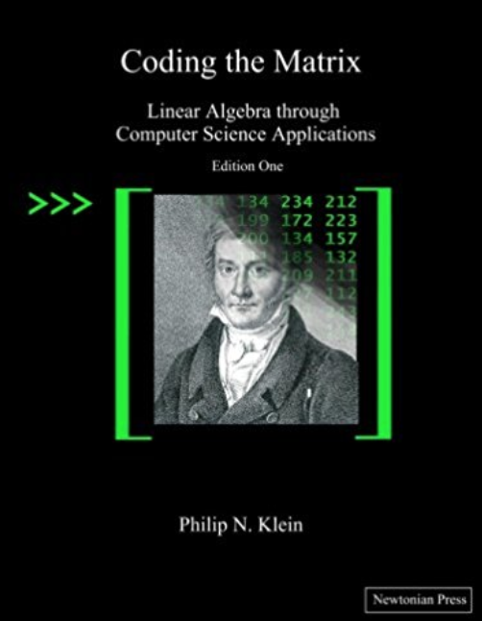

img

Coding the Matrix — the best Linear Algebra book ever!